School of Digital Media & Infocomm Technology (DMIT)
ST1011 Applications Development
Practical 3 Part 2
Object Oriented Programming - Advanced Topics

Objectives:
After completing this lab, you should be able to:
- Demonstrate understanding of encapsulation in Object-Oriented Programming.
- Determine the classes, properties and methods for an Object-Oriented application.
- Demonstrate the use of inheritance in Object-Oriented programming.
- Demonstrate the use of dynamic types using polymorphism, method overloading and overriding.
Develop an application with good object-oriented design.

You are given the following fragment of a class diagram and the description of the classes for the system. You are to develop a prototype for the system.

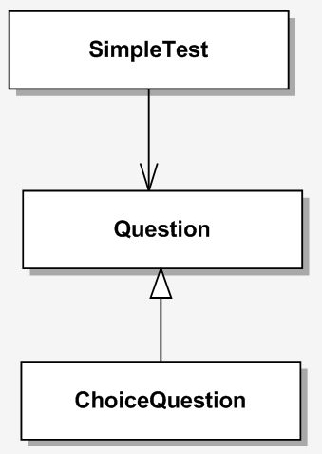
contains
1
0..*

Class Question:
This class simulates any generic question in the system that has a text (the question itself) and an answer. It can display the question and check the response against the answer.

Class ChoiceQuestion:
This class simulates multiple-choice-question in the system. Each question has only one correct answer. Just like any question, multiple-choice-question has a text and an answer as well. On top of that, it is able to store 3 to 5 choices for the question; it has a method to add the answer choices and when displaying the question, the choices are displayed together with the question so that the respondent can choose one of the choices.

Class SimpleTest:
This class models a test in the system. Each test has several questions. A question could be an object of any of the two classes described above. A test has a score that corresponds to the number of correct answers.

Based on the description given, you are required to:

- Implement the Question class. You should include the following in the class:
- The variable(s) according to the description given above.
- The default constructor that does nothing.
- The properties for the attributes.
- The checkAnswer(string) method that receives the response as the argument and returns true if the a response is the same as the answer, false otherwise.
- The method displayQuestion() that displays the question.

- Implement the ChoiceQuestion class. You should include the following in the class:
- The variable(s) according to the description given above if any.
- The properties for the attributes if any.
- The default constructor if required.
- The method addChoice() with the following method signature:
public void addChoice(string choice, bool correct)
This method adds a choice for the question. The boolean value is true if the choice is the correct answer, false otherwise. The method sets the answer for the question.
- The method displayQuestion() that displays the question together with the choices provided. The choices are to be labeled with numbers 1 through n.

- Implement the SimpleTest class. You should include the following in the class:
- The variable(s) according to the description given above.
- The default constructor if required.
- The method that adds a question to the list.
- The method startTest() that performs the following tasks:
- display each question from the list onto the screen
- prompt the user for his response
- check the response and display the result (correct or incorrect)
- update the score
- The method calculatePercentage() that calculates the percentage score (e.g. if he gets 3 out of 5 questions correct, the percentage score will be 60%).

- Implement the Program.cs class to simulate the online test. The class should perform the following tasks:
- Create a SimpleTest object.
- Add some questions into the SimpleTest object. The questions should include all 2 question types given in the class diagram. Moreover, there should be more than one multiple-choice-question, each has different number of choices.
- Prompt the user for his name before start the test.
- Start the test.
- Report the test result.

Advanced questions - OPTIONAL

- Implement a SimpleQuestion class as an interface. The interface should contain appropriate methods such as GetQuestion and GetText. Modify the other classes to use SimpleQuestion interface.

- What is the difference between Abstract class and Interface?

- END -

